Ben Bowling Summary

Wether Py Findings

While reviewing the relationship between latitude and temperature, I found that the closer you are to 0 degrees latitude (the equator), the higher the temperature will be.

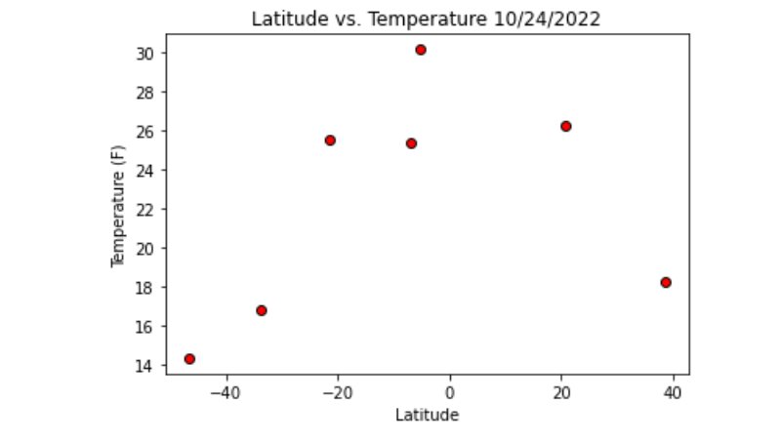

While reviewing the relationship between latitude and humidity, the data shows that the closer you get to the northern hemisphere, the more you are likely to see an increase in humidity.

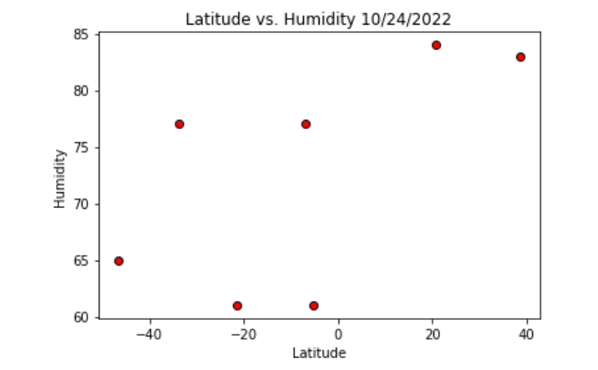

While reviewing the relationship between latitude and wind speed, the data shows that the closer you are to the southern hemisphere, the more wind speed will increase.

